VySkan
Product Name | 2G Wide-Voltage GPS Vehicle Tracker
Product Model | VM90-2G
Reliable. Cost-Effective. Wide-Voltage.
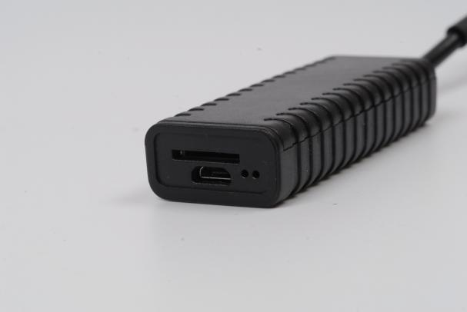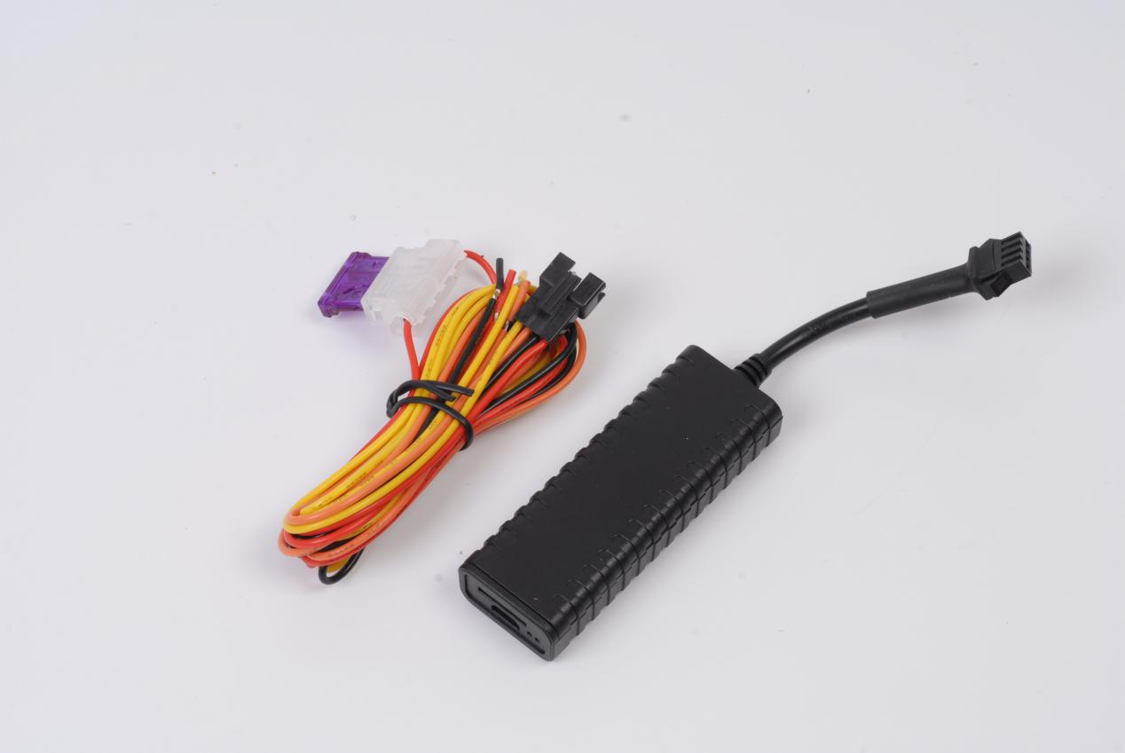
Engineered for cost-sensitive fleet management and auto finance operations, the VM90-2G is a highly stable 2G vehicle tracker featuring GSM wireless communication and GPS/BDS satellite navigation. Featuring a built-in industrial-grade antenna and a highly integrated design, it delivers essential real-time tracking, asset protection, and intelligent power management in a highly cost-effective package.
- Core Value
- Universal 9V-90V Compatibility
Designed to operate seamlessly across an ultra-wide DC 9V to 90V range, making it a universal solution for everything from e-bikes and passenger cars to heavy-duty trucks.
- Intelligent Power Management
Built with a 3-axis accelerometer and a smart sleep/wake mechanism, the device automatically enters sleep mode (drawing less than 10mA) when stationary to protect the vehicle's battery life.
- Comprehensive Remote Asset Defense
Supports multiple security alerts, including vibration, power-cut, over-speed, illegal start, and displacement alarms. It also allows fleet managers to execute remote fuel and power cut-off commands.

- Zero Data Loss Architecture
Equipped with a built-in large-capacity storage chip, it automatically caches trajectory data when entering cellular blind zones and seamlessly uploads the stored data once the network is restored.
- Target Applications
- Insurance & Auto Finance: (Risk management, illegal start alerts).
- Corporate Fleets & Logistics: (Wide voltage, remote fuel/power cut).
- E-bikes & New Energy Vehicles: (9-90V support, low power consumption).
- Technical Specifications
  - Cellular & GNSS
Category | Specification | Description
Network Bands | 2G  GSM:850/900/1800/1900MHz | Global 2G quad-band support.
SIM Card | Micro SIM | Built-in push-push slot.
GNSS Module | GPS + BDS | High-sensitivity dual-star positioning.
Positioning Accuracy | < 10 meters | Reliable real-time asset visibility.
Start Time | Cold: Avg 32s |Hot: Avg 1s | Rapid satellite acquisition supported by AGPS.
  - Power & Electrical
Category | Specification | Description
Operating Voltage | DC 9V - 90V | Ultra-wide range compatible with a vast array of vehicles.
Working Current | Avg 35mA @ 12V | Standard active tracking mode.
Sleep Current | < 10mA @ 12V | Ultra-low power consumption.
Backup Battery | 80 mAh / 3.7V Li-Polymer (Optional) | Enables power-cut alarms upon main power disconnection.

3.3 Interfaces & Expandability
Category | Specification | Description
Smart Alarms | Vibration, Power-cut, Over-speed, Illegal Start | Multi-layered alert system for proactive security.
Vehicle Control | 1 Channel Fuel/Power Cut | Supports external relay for remote immobilization.
Ignition Detection | 1 Channel ACC Detection | Accurately monitors vehicle start/stop status.
3.4 Physical & Environmental
Category | Specification | Description
Dimensions | 75mm × 27mm × 14mm | Compact footprint.
Weight | 30g | Lightweight design.
Housing Material | ABS Plastic | Industrial-grade durability.
Operating Temp. | -20℃ to 75℃ | Reliable operation in diverse conditions.

- Built for Rapid Integration
- Standard Protocols: Natively supports TCP transmission and offers a choice between standard JTT808 or GT06 protocols.
- OTA Ready: Supports dual-mode remote upgrades (Platform + SMS) to minimize maintenance costs.
- A personalized service prepared for you
- 1× VM90-2G Sample Device (Pre-configured)
- Full API & Protocol Documentation
- 1-on-1 Technical Support from our Field Engineers
- Contact us
Website：https://vyskan.com/
Email: marketing@vyskan.com

